CE 120 – Preliminary Failure Assessment

Section (circle): | A B C D E F G H I J K | Date:
Group (circle): | 1 2 3 4 5 6 7 8 9 10 11 12 13 14 15
Data Recorder:

COMPONENT 1
Failed component’s number: __________

Use the provided failure mode taxonomy, to select the component’s primary identifier and failure mode.

Primary identifier: ________________________ Failure mode: _________________________________

Why did you select this failure mode?

COMPONENT 2
Failed component’s number: __________

Use the provided failure mode taxonomy, to select the component’s primary identifier and failure mode.

Primary identifier: ________________________ Failure mode: _________________________________

Why did you select this failure mode?

COMPONENT 3
Failed component’s number: __________

Use the provided failure mode taxonomy, to select the component’s primary identifier and failure mode.

Primary identifier: ________________________ Failure mode: _________________________________

Why did you select this failure mode?

Label where your three components would be on the following failure wheel.
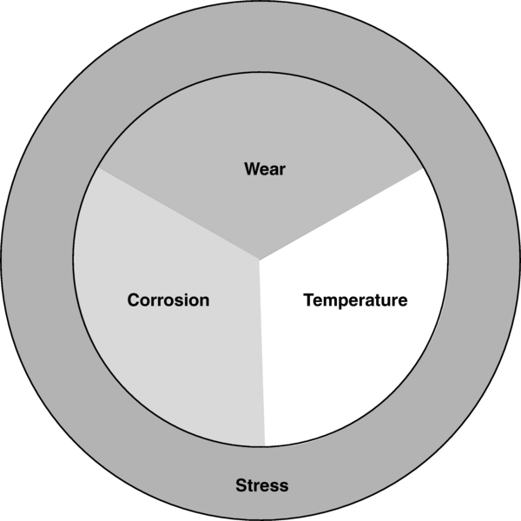

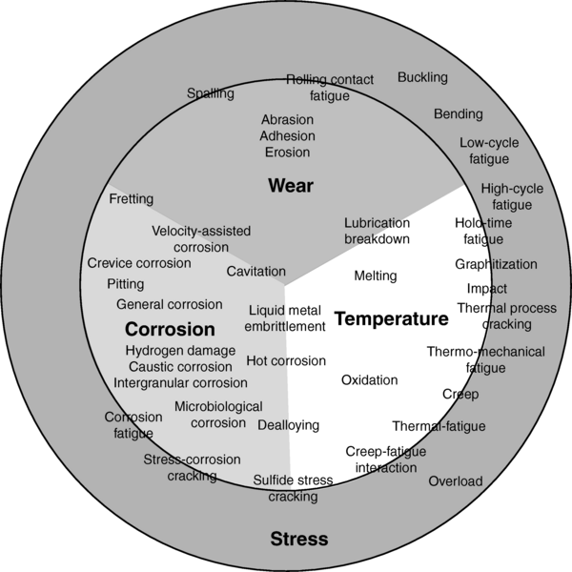

A. Tanzer, Determination and Classification of Damage, Failure Analysis and Prevention, Vol 11, ASM Handbook, ASM International, 2002, p 343–350

