**Pressure Vessels**

Worksheet

Section:

Group Members:

**Thin-Walled Vessel**

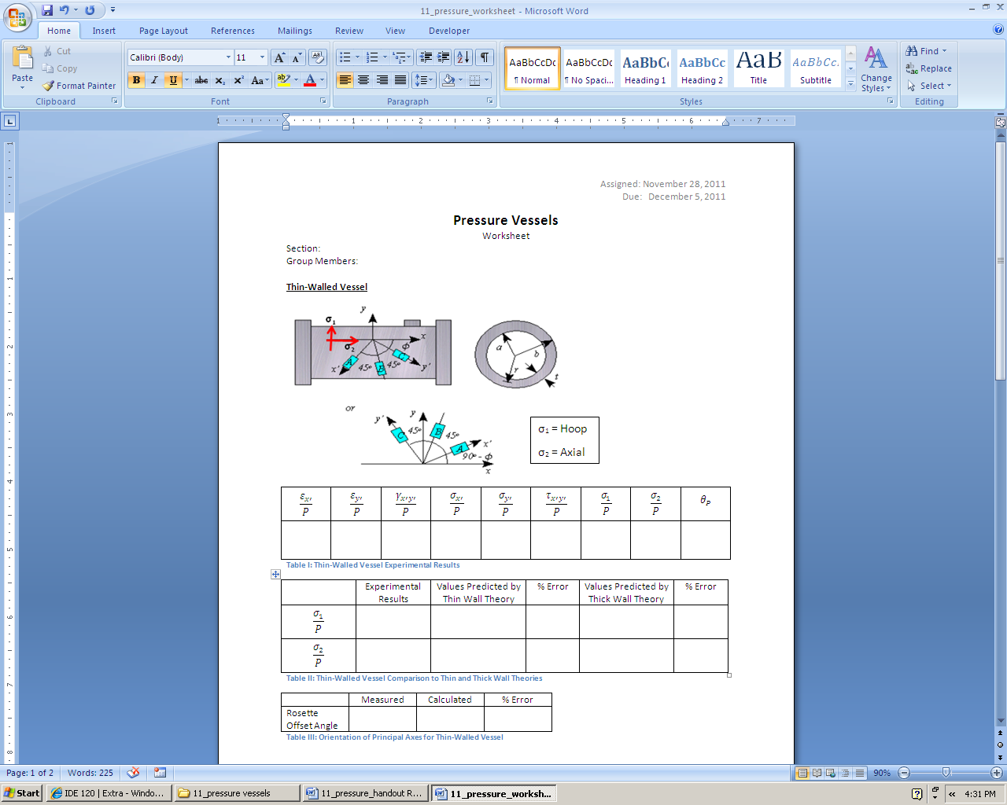

|  |  |  |  |  |  |  |  |  |
| --- | --- | --- | --- | --- | --- | --- | --- | --- |
|  |  |  |  |  |  |  |  |  |
|  |  |  |  |  |  |  |  |  |

Table : Thin-Walled Vessel Experimental Results

|  |  |  |  |  |  |
| --- | --- | --- | --- | --- | --- |
|  | Experimental Results | Values Predicted by Thin Wall Theory | % Error | Values Predicted by Thick Wall Theory | % Error |
|  |  |  |  |  |  |
|  |  |  |  |  |  |

Table : Thin-Walled Vessel Comparison to Thin and Thick Wall Theories

|  |  |  |  |
| --- | --- | --- | --- |
|  | Measured | Calculated | % Error |
| Rosette Offset Angle |  |  |  |

Table : Orientation of Principal Axes for Thin-Walled Vessel

**Thick-Walled Vessel**

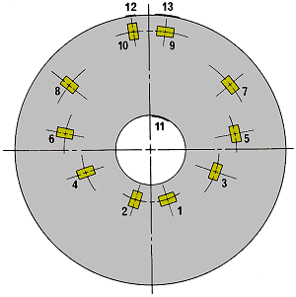

σ1

σ3

σ1 = Hoop

σ3 = Radial

|  |  |  |  |
| --- | --- | --- | --- |
|  |  |  |  |
|  |  |  |  |

Table : Thick-Walled Vessel Experimental Results

|  |  |  |  |  |  |
| --- | --- | --- | --- | --- | --- |
|  | Experimental Results | Values Predicted by Thin Wall Theory | % Error | Values Predicted by Thick Wall Theory | % Error |
|  |  |  |  |  |  |
|  |  |  |  |  |  |

Table : Thick-Walled Vessel Comparison to Thin and Thick Wall Theories

|  |
| --- |
| **Attach data sheet and both Excel Plots**  **Attach a separate sheet with a short paragraph discussing the following points:**   * **Briefly comment on how accurate the theories are for each vessel based on percent error.** * **Comment on how well the calculated orientation of the principal axes match up with the actual principal axes (thin walled vessel). The principal axes should theoretically be aligned with the hoop and axial directions.** |

**Turn in both pages of this worksheet, your data sheet, your two Excel plots, and the discussion paragraph to the appropriate TA’s mailbox by 5:00pm December 5, 2011.**